Output Screenshots For Guvi Task 6

Snippet 1

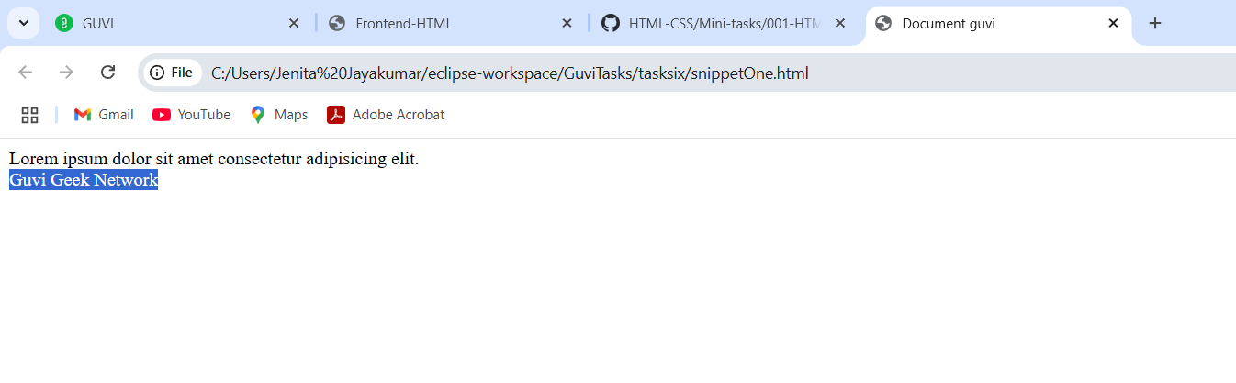

Snippet 2

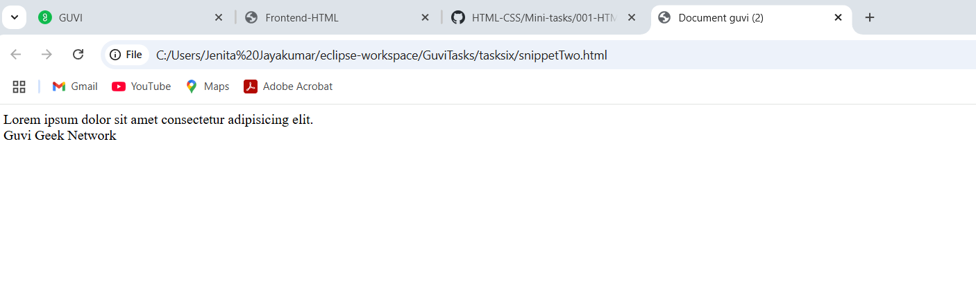

Contact Us Form

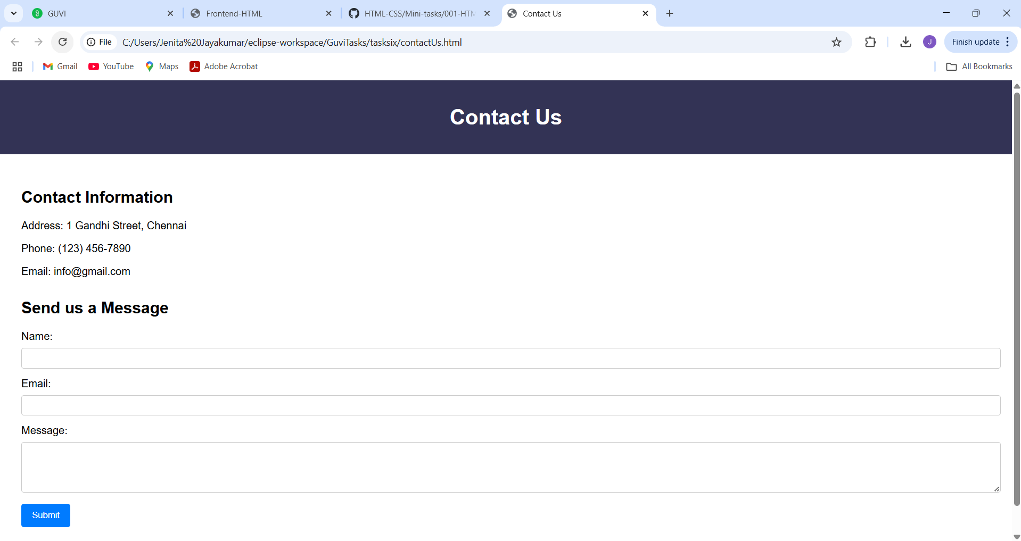

Types of Lists

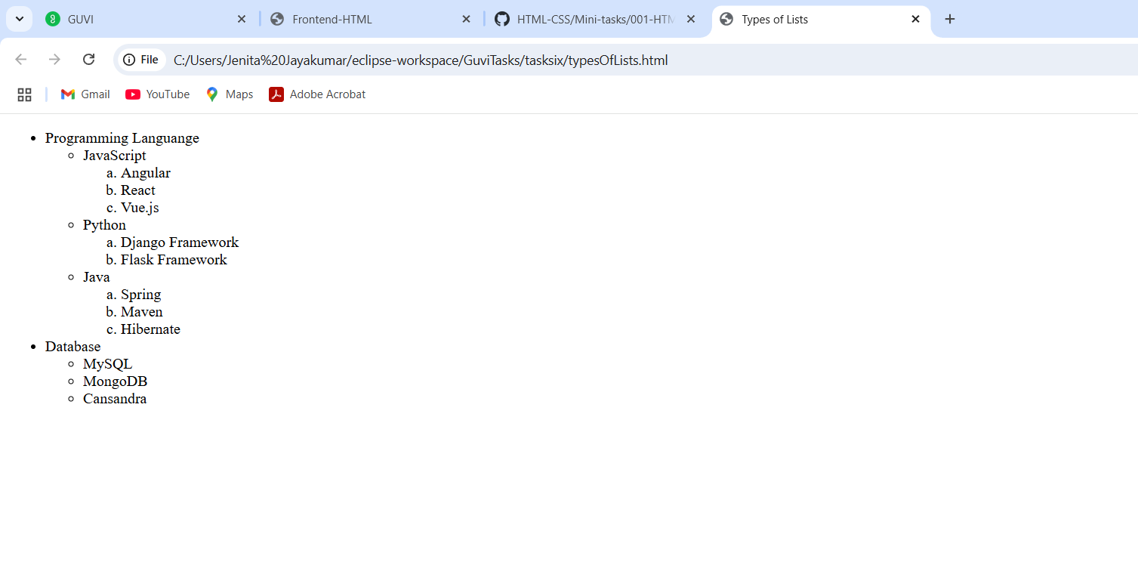

New Tab Open

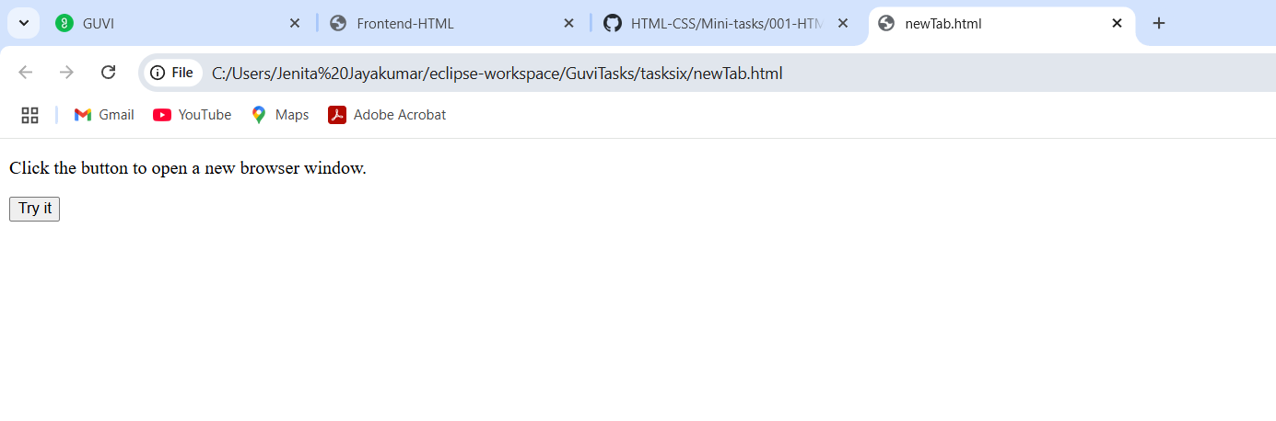

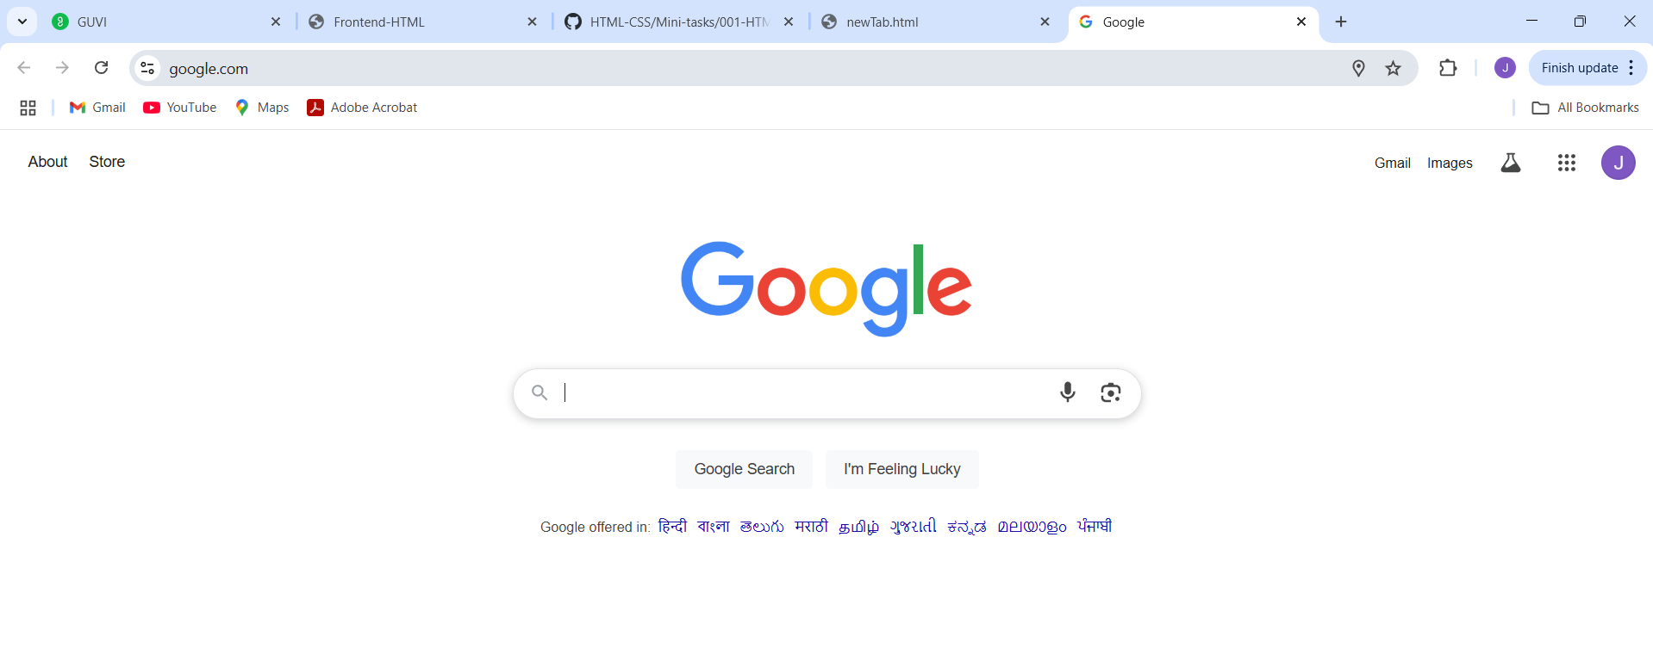

Radio buttons

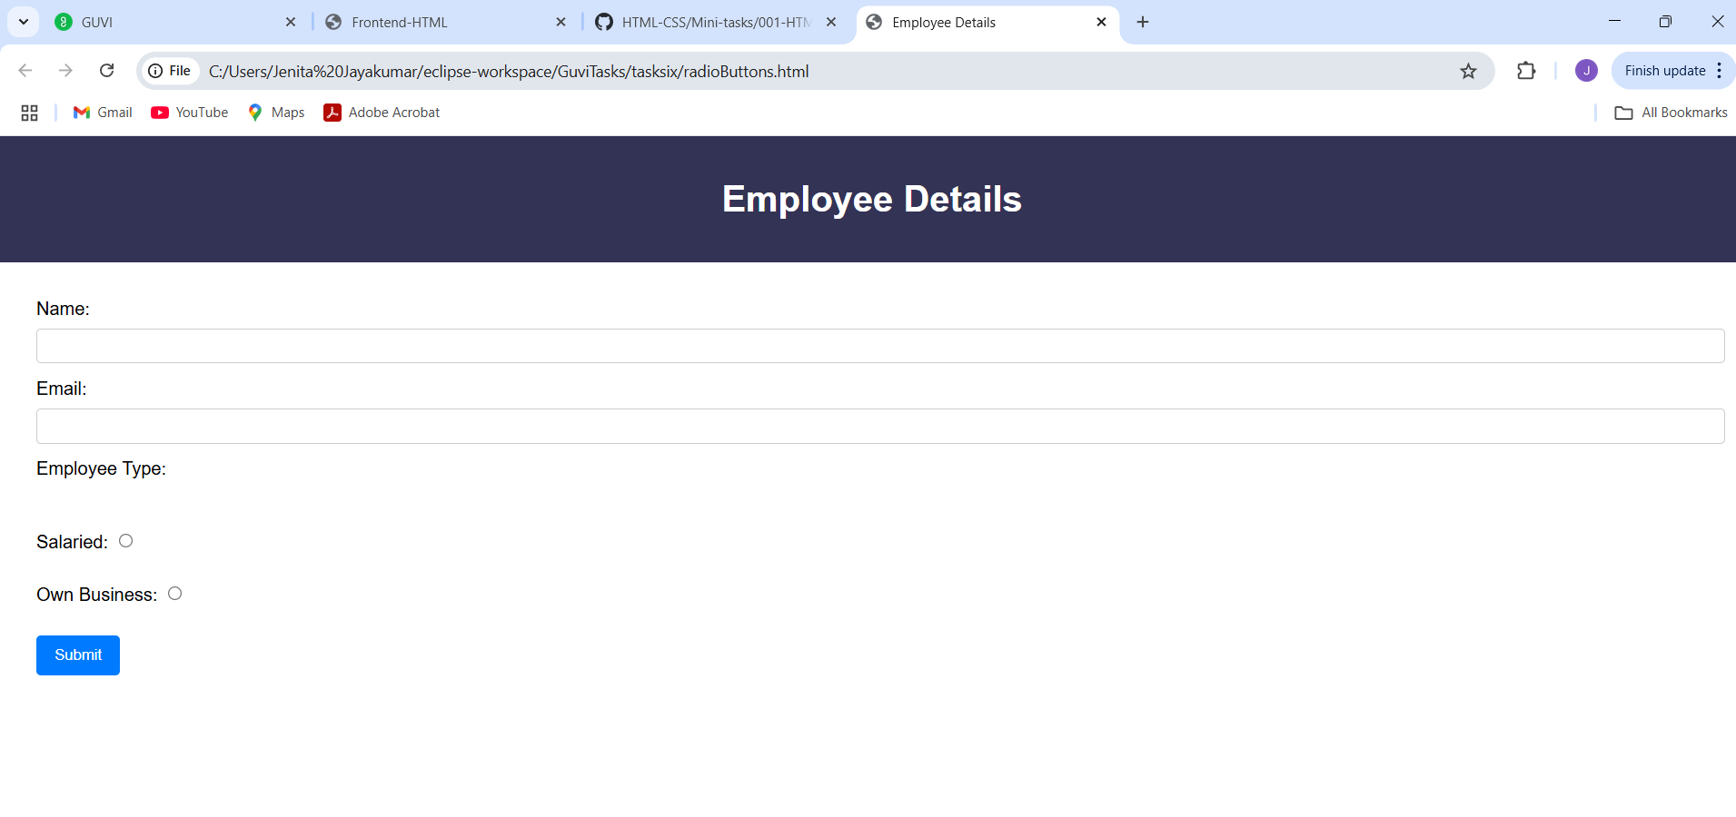

Design form (link not working)

1. Design form shown in the link (<http://evc-cit.info/cit040/formguide/card_0.png>)

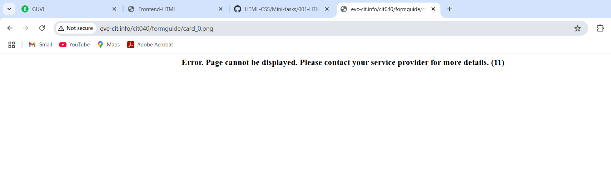

Table tag (page unavailable)

1. Use the table tag to design given image [Click here](https://www.bapugraphics.com/assets/img/port_upload_dir/table-4.jpg).

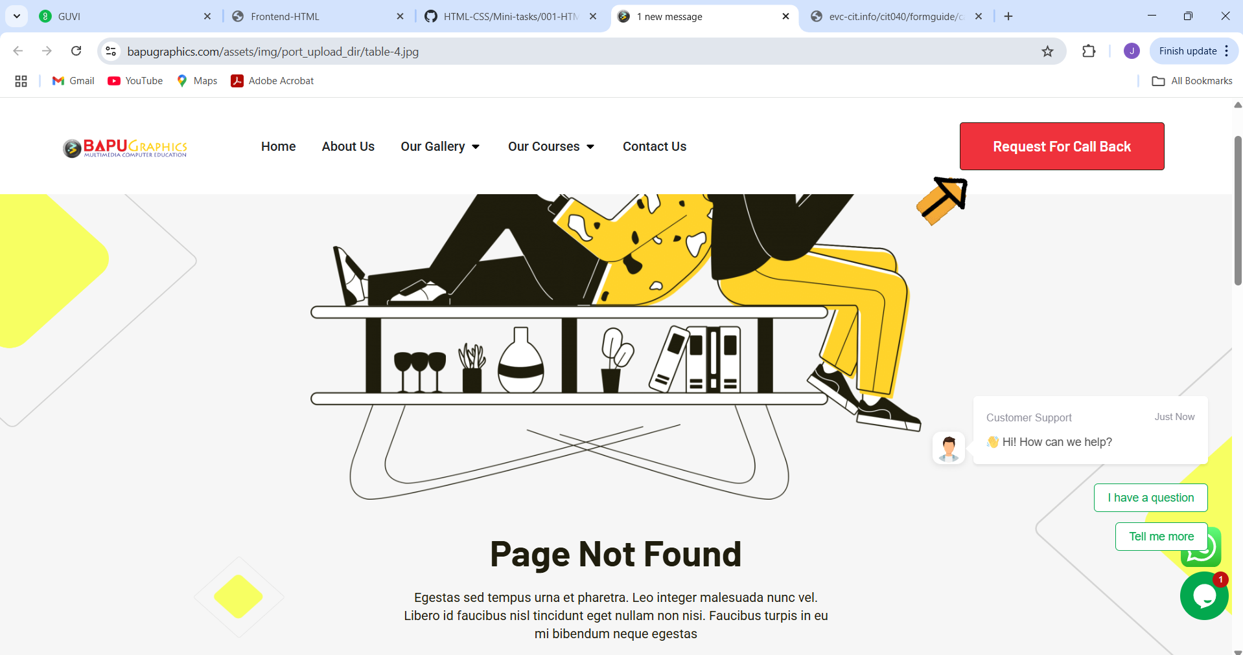

Default Input Tags

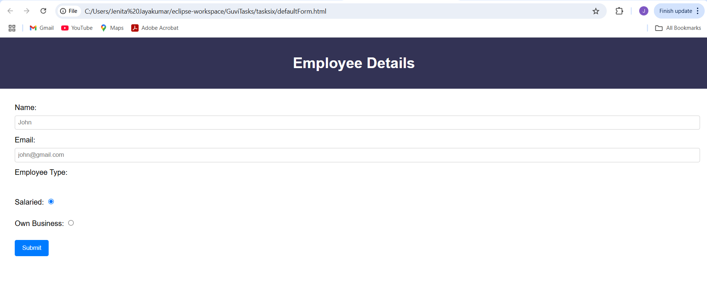

Highlight Text

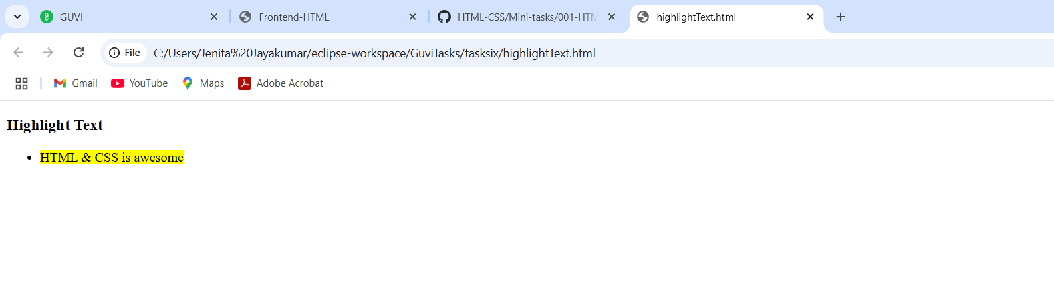

All Input Elements in a form

